Project Demonstration

1. Introduction
The Human Development Index (HDI) Prediction project was developed to demonstrate the practical application of Machine Learning in predicting a country's Human Development Index based on socio-economic indicators. The project combines data preprocessing, model training, and a Flask-based web application to provide users with an easy-to-use prediction system.
2. Demonstration Objectives
The demonstration aims to:
- Explain the project workflow.
- Showcase the Machine Learning model.
- Demonstrate the Flask web application.
- Display prediction results.
- Highlight the practical applications of the system.
3. Demonstration Steps

Step 1: Open the Application
Run the Flask application using:
python app.py
Open the application in a web browser.
Step 2: Enter Input Values
Provide the following information:
- Life Expectancy at Birth
- Expected Years of Schooling
- Mean Years of Schooling
- Gross National Income (GNI) per Capita
Step 3: Generate Prediction
Click the Predict button.
The application processes the input values using the trained Machine Learning model and predicts the Human Development Index.
Step 4: View Result
The predicted HDI value is displayed on the screen.
4. Screenshots
Insert the following screenshots in this section:
- Home Page
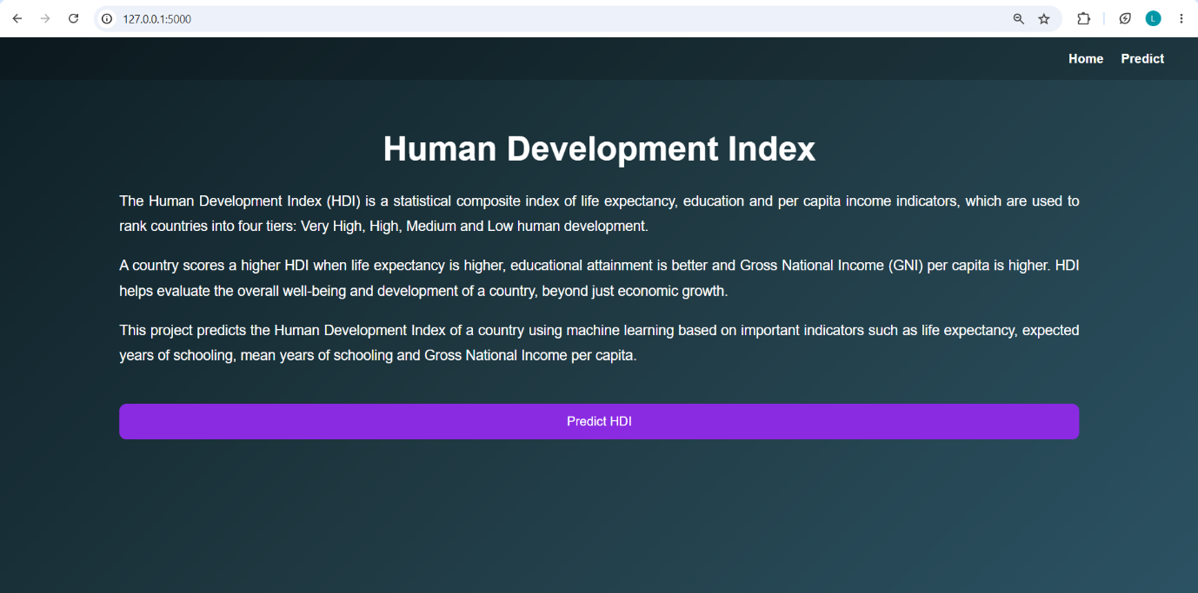
- Prediction Page
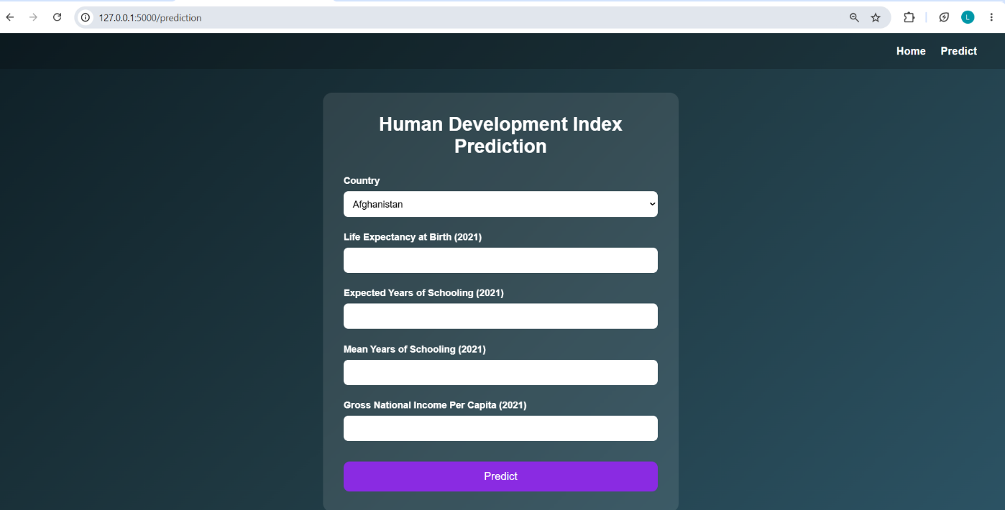

- Prediction Result Page
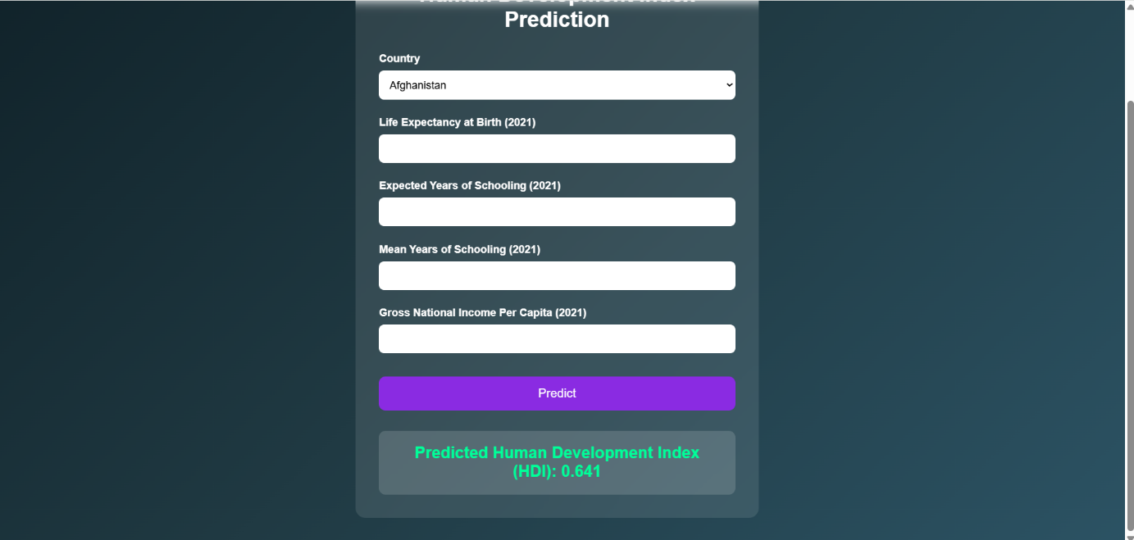
- GitHub Repository
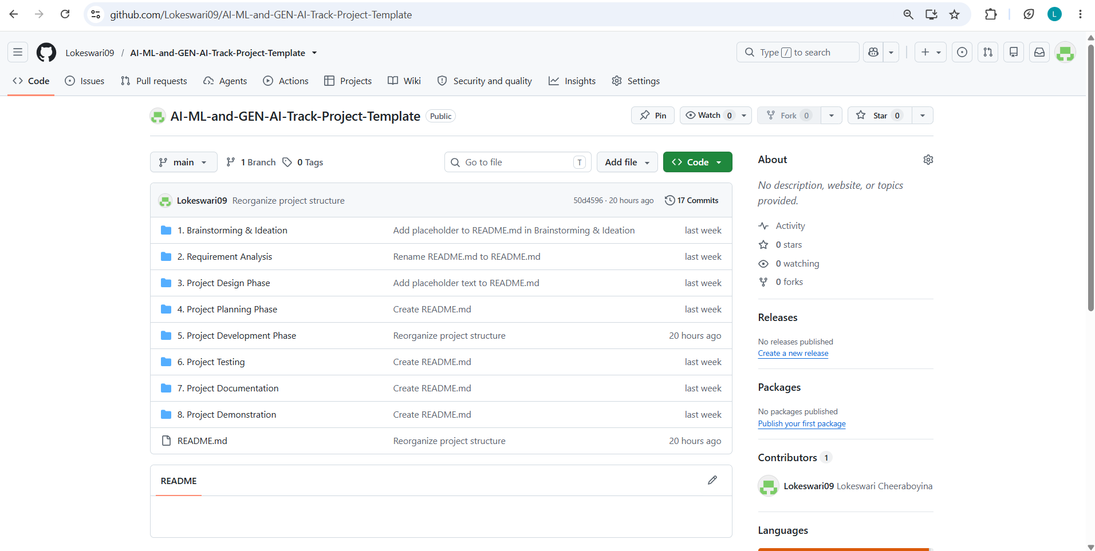

5. Project Features
- Predicts Human Development Index using Machine Learning.
- User-friendly Flask web application.
- Fast and accurate prediction.
- Simple interface for entering socio-economic indicators.
- Uses a trained Linear Regression model.

6. Applications
The project can be used by:
- Students
- Researchers
- Educational Institutions
- Government Organizations
- Policy Makers

7. Future Scope
The project can be enhanced by:
- Implementing advanced Machine Learning algorithms.
- Deploying the application on cloud platforms.
- Integrating real-time datasets.
- Adding interactive data visualizations.
- Developing a mobile application.
8. Conclusion
The Human Development Index Prediction project successfully demonstrates the integration of Machine Learning and web technologies. The application provides an efficient, accurate, and user-friendly solution for predicting HDI values based on socio-economic indicators. The project showcases practical skills in data preprocessing, model development, and web deployment.

